Activity Diagram for Diabetes Detection
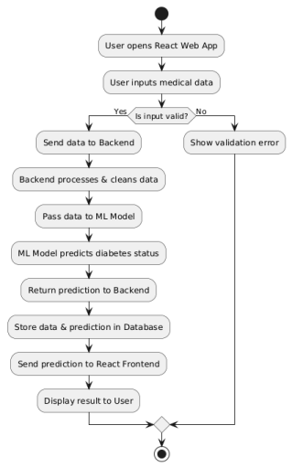
This diagram outlines the workflow or control flow of the diabetes detection system, showing the sequence of activities and decisions taken during the process. Here's a breakdown:
- Start Node: The process begins when a user accesses the system.
- User Input: The user provides relevant health data (e.g., glucose levels, BMI, age).
- Preprocessing: Data is cleaned, normalized, or scaled for model compatibility.
- Model Loading: The machine learning model (e.g., trained on Pima Indian Diabetes Dataset) is loaded.
- Prediction: The input data is passed to the model, which predicts whether the user is diabetic or not.
- Decision Node:
  - If the result is positive: Display “Diabetes Detected” and suggest further medical advice.
  - If the result is negative: Display “No Diabetes Detected” with lifestyle recommendations.
- End Node: The system ends the activity.
- Purpose: This diagram helps in understanding the user flow and decision logic of the diabetes detection app.

Sequence Diagram for Diabetes Detection
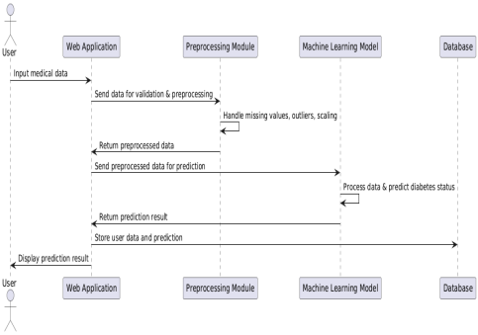
This diagram shows the interaction between various system components over time, represented as a sequence of messages exchanged.
- Actors:
  - User: Initiates interaction.
  - UI Layer: Accepts user input.
  - Controller: Validates and forwards input.
  - Model/ML Engine: Makes the prediction.
  - Database (optional): May log predictions or retrieve historical data.
Steps:
- User enters health details in the UI.
- UI sends data to the controller.
- Controller requests prediction from the ML model.
- ML model returns the prediction result.
- Controller forwards the result to UI.
- UI displays the result to the user.
- Purpose: Helps visualize how different parts of the system (UI, backend, ML model) interact in real time.
System Architecture for Diabetes Detection
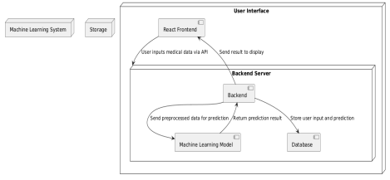
This is a high-level overview of the system components and how they interact.
- Frontend (User Interface):
  - Built with Streamlit or web framework.
  - Collects user input and displays output.
- Backend / Application Layer:
  - Processes user input.
  - Calls the ML model for predictions.
  - Handles business logic.
- Machine Learning Model:
  - Pretrained model (e.g., Random Forest, Naive Bayes).
  - Receives cleaned input, returns prediction.
- Database (Optional):
  - Stores user data, logs, or historical results.
- External Tools:
  - May include libraries like Scikit-learn, Pandas, etc.
- Purpose: Shows the deployment setup and how components like frontend, backend, and ML model are connected.

